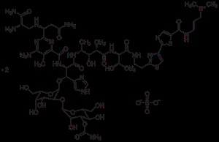

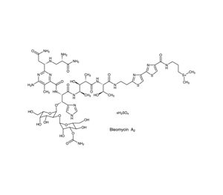
Bleomycin is a cytotoxic glycopeptide antibiotic primarily used as a chemotherapy drug to treat several cancers, including Hodgkin's lymphoma, non-Hodgkin's lymphoma, testicular and ovarian cancer, cervical cancer, head and neck cancers, and squamous cell carcinomas124710.
- Mechanism of Action: Bleomycin interferes with DNA synthesis, making it particularly effective against rapidly dividing cells such as cancer cells132.
- Administration: It can be given intravenously, intramuscularly, subcutaneously, or injected directly into tumors or body cavities (such as for malignant pleural effusions)256.
- Side Effects: Common side effects include fever, vomiting, skin rashes, and weight loss1. The most serious risk is lung toxicity (including potentially life-threatening pulmonary fibrosis), especially at higher cumulative doses or in older patients; regular lung function monitoring is recommended19. Other possible effects include skin changes (darkening), hair loss, and kidney impairment45.
- Special Precautions: Not recommended for children, pregnant, or breastfeeding women. Caution is needed in patients with renal or pulmonary impairment56.
- Other Uses: Occasionally used for difficult-to-treat skin lesions like warts in immunocompromised people and to manage recurrent malignant pleural effusions156.
Bleomycin is considered an essential medicine by the World Health Organization and is available as a generic drug1. Its use should be supervised by experienced healthcare professionals due to its potential for serious side effects45.
- https://en.wikipedia.org/wiki/Bleomycin
- https://www.cancerresearchuk.org/about-cancer/treatment/drugs/bleomycin
- https://go.drugbank.com/drugs/DB00290
- https://www.mayoclinic.org/drugs-supplements/bleomycin-injection-route/description/drg-20067165
- https://www.empr.com/drug/bleomycin/
- https://chemocare.com/druginfo/bleomycin
- https://www.ncbi.nlm.nih.gov/books/NBK555895/
- https://www.oncolink.org/cancer-treatment/oncolink-rx/bleomycin-blenoxane-R
- https://medlineplus.gov/druginfo/meds/a682125.html
- https://my.clevelandclinic.org/health/drugs/19954-bleomycin-injection

